Generic IIR-Filter

Design
This filter is implemented as a direkt implementation of a IIR-Filter. The following width apply to the different signal paths:
(WIDTH) bits:
- my_inputs
- x
- y
(WIDTH + N_WIDTH) bits:
- my_mults
- my_sum
Note that this means that some information will be lost when my_sum(0) is written to the output, y.
During design the following assumptions and limitations were made:
- The result will fit into an equal amount of bits as the input is. If this isn't the case, then you can increase the number of bits on the input to increase the output bits as well.
- All internal calculations will fit onto WIDTH + N_WIDTH bits. If this isn't the case, the internal bits can be increased by increasing the coefficient bits and N_WIDTH.
- The output will have the same amount of binals as the input.
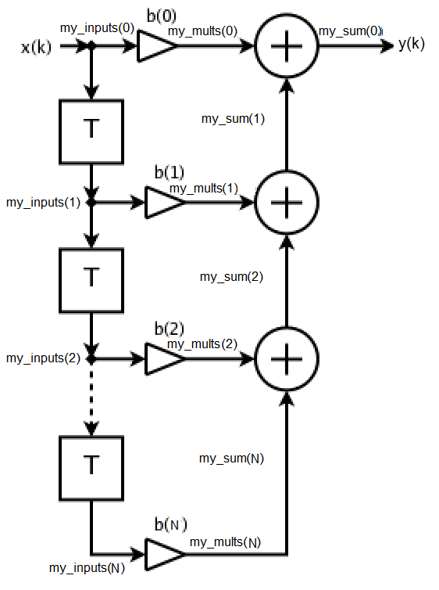

Generics
WIDTH : integer
The number of bits on the input and output
N : integer
The order of the filter

Input/Output Signals
Clk : in std_logic
System clock to clock input. Input is clocked on rising flank.
clk_en : in std_logic
Clock enabel, input is clocked when enable is high.
x : in std_logic_vector(WIDTH-1 downto 0)
Input data.
y : out std_logic_vector(WIDTH-1 downto 0)
Output Data

Internal Constants
N_WIDTH : integer
Number of bits on the coefficients
N_BINALS : integer
Number of binals in the coefficients

Timing
Results from the input is immidiatly put on the output after the next rising flank

